5. ReactJS-HOL

CohortDetails.js

import React from 'react';

import styles from './CohortDetails.module.css';

function CohortDetails({ cohort }) {

const { name, startDate, status, coach, trainer } = cohort;

const titleStyle = {

color: status === 'Ongoing' ? 'green' : 'blue'

};

return (

<div className={styles.box}>

<h3 style={titleStyle}>{name}</h3>

<dl>

<dt>Started On</dt>

<dd>{startDate}</dd>

<dt>Current Status</dt>

<dd>{status}</dd>

<dt>Coach</dt>

<dd>{coach}</dd>

<dt>Trainer</dt>

<dd>{trainer}</dd>

</dl>

</div>

);

}

export default CohortDetails;

CohortDetails.module.css

.box {

width: 300px;

display: inline-block;

margin: 10px;

padding: 10px 20px;

border: 1px solid #999;

border-radius: 10px;

vertical-align: top;

}

dt {

font-weight: 500;

margin-top: 10px;

}

App.js

import React from 'react';

import CohortDetails from './components/CohortDetails';

function App() {

const cohorts = [

{

name: "INTADMDF10 - .NET FSD",

startDate: "22-Feb-2022",

status: "Scheduled",

coach: "Aathma",

trainer: "Jojo Jose"

},

{

name: "ADM21JF014 - Java FSD",

startDate: "10-Sep-2021",

status: "Ongoing",

coach: "Apoorv",

trainer: "Elisa Smith"

},

{

name: "CDBJF21025 - Java FSD",

startDate: "24-Dec-2021",

status: "Ongoing",

coach: "Aathma",

trainer: "John Doe"

}

];

return (

<div style={{ padding: '20px' }}>

<h1>Cohorts Details</h1>

{cohorts.map((cohort, index) => (

<CohortDetails key={index} cohort={cohort} />

))}

</div>

);

}

export default App;

Index.js

import React from 'react';

import ReactDOM from 'react-dom/client';

import App from './App';

const root = ReactDOM.createRoot(document.getElementById('root'));

root.render(<App />);

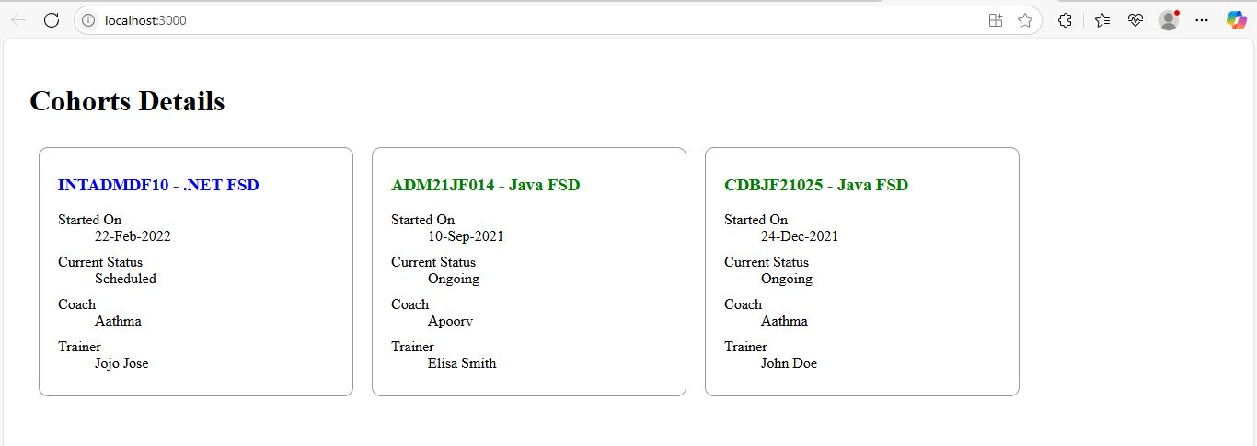



1. Understanding the need for styling React components
Styling in React enhances the UI by improving readability, structure, and user experience. It helps developers:
- Visually distinguish components
- Reflect the application's brand
- Maintain modular and reusable styles using scoped CSS like CSS Modules

2. Working with CSS Modules and Inline Styles
CSS Modules allow defining scoped styles. They avoid global CSS conflicts.
Inline styles are applied directly in JSX using JavaScript objects. Useful for dynamic styling (e.g., based on a condition).

